Michael Surdek
Project Management Plan
Fabricant Corporation
Final Project Plan



Submitted to:
Dr. Randy Butler
Project Initiation
Feasibility
Fabricant Corporation, a specialized metal parts manufacturer and distributor, considered three project proposals with the hopes of undertaking at least one that might create shareholder value and demonstrate corporate social responsibility via energy conservation and community awareness. The project that they chose to pursue involves replacing old lighting fixtures with motion sensors and LED technologies throughout their office and manufacturing plant. They selected the lighting project as it is nearly a sure thing to surpass their hurdle rate when it comes to financial metrics such as return on investment and internal rate of return. Additionally, this project can be completed without using external resources or consulting many external stakeholders, making it more likely to be successful than the alternatives. It will also be feasible under the company’s matrix organization structure by taking place within their manufacturing and facilities functions and being managed by internal project coordinator, Vivian Liu.
Strategic Goals
The LED lighting retrofit project is aligned with all three of Fabricant’s strategic objectives, reducing energy consumption by at least 20%, generating a return on investment of 15% or higher and raising community consciousness of environmental issues and concerns. The new lighting fixtures are expected to produce energy savings of over 1.1 million kWh per year. When compared to the 9.5 million kWh of electricity that the facility currently consumes each year, this represents an 11.5% reduction in energy consumption. Although that does not exceed the company’s goal of 20%, it is a step in the right direction and it makes the relatively small investment of $75,000 more than worthwhile. These energy savings also lead directly to $142,000 annually in monetary savings, which is an 89% return on investment in just the first year. This return is well above the ROI hurdle rate of 15%, considering the LED lightning will reduce energy consumption for years to come. To align with the third goal of community awareness, the Head of Strategic Planning recommended that the initiative be included on the company’s website, newsletter, and client literature. Although the alternative projects may have been more visible to the community, these steps will ensure that their corporate social responsibility efforts are broadcast through major channels.
Project Charter
The project charter must be completed in order to formally authorize the existence of a project and to authorize the project manager to use resources for the project. The charter outlines the scope, goals, and deadlines at a high level, with enough detail to be continuously used as a reference, but not so much that it is overwhelming. It is important that the charter sets boundaries for the project, highlights uncertainty, and takes all stakeholders into consideration.
Project Title
Industrial Lighting Retrofit

Date
08/15/2021

Business Case
To reduce energy consumption, increase profit, and demonstrate corporate social responsibility to the community

Project Purpose
Replace existing interior and exterior lighting in all Fabricant workspaces, warehouses, and break rooms with new technologies

Project Objectives
Fabricant's strategic objectives are the following: create shareholder value and demonstrate corporate social responsibility by continuing to be a leader in energy conservation, research, and development of advanced technologies.

Project Deliverables
- Comprehensive energy audit of each building;
- Recommendations for targeted lighting systems and cost-effective replacement technologies
- Life cycle cost analysis and economic evaluation that factors in cost, maintenance cost, and utility cost over the expected life of the building lighting retrofit
- Waste management plan for disposal of hazardous materials, submitted in accordance with EPA guidelines
- Procurement of necessary retrofit materials and electrical components
- Detailed demolition and installation requirements, including procedures to shut down electric, disarm fire alarm system, remove materials from property, and protect computer and other equipment
- Completion of all necessary permit applications and certificates
- Plan to comply with all Occupational Safety and Health Program requirements (containment of dust, debris, contaminants)
- Submission of drawings and construction phase schedule
- Completion of Phase 1 lighting replacement: Corporate offices
- Completion of Phase 2 lighting replacement: Production shop offices and break rooms
- Completion of Phase 3 lighting replacement: Production floor
- Completion of Phase 4 lighting replacement: Warehouse and parking lots
- Installation of sensors and motion detectors
- Delivery of computer model with baseline energy usage and automated tracking system
- Submission of project close-out documentation

Project Personnel
- Vivian Liu, Project Manager
- Sam Massoni, American Grid Program Manager
- Trudy Noble, Environmental Manager
- Paul Callahan, Distribution Logistics Manager
- Elwood Vaughn, Systems/IT Director
- Perry Silverman, Finance Analyst
- Jeff Salvatore, PR/Communications Manager
- Emmitt McAuley, OSHA liaison
- Matt Stevens, Strategic Planning Assistant

Risks
- Costs will exceed estimates and ROI will be less than expected
- Team members do not possess all necessary skills to carry out necessary project activities
- Replacement work will disrupt production activities and delay output
- New technologies will fail to deliver expected energy efficiencies
- Removal and disposal of hazardous materials in old lighting systems

Schedule Summary
Three months from kickoff

Budget Summary
Project cost estimate of $310,000, with expected offsets of $245,000

Measurable Success Criteria
- Demonstrated reduction in energy consumption, as measured in comparison to baseline audit
- Improved lighting conditions

Other Project Limitations
- Vivian having several other large projects on her plate
- Production team dealing with mess and disruption from the project

Approval Signatures/Approval Date
Janice Scott - 08/15/2021

High-Level Timeline
The high level timeline is the midpoint between the milestone chart and the work breakdown structure. Using the milestone chart, which shows the expected and actual completion of product increments and deliverables, the high level timeline goes into more detail by breaking the increments into smaller tasks and estimating their duration and costs. This timeline can be used to get an idea of the total duration and cost of the entire project. The work breakdown structure is then created from the milestone chart and the high level timeline by breaking the tasks down into work packages, which can be assigned to individuals who are responsible for them. (MindEdge Module 3)
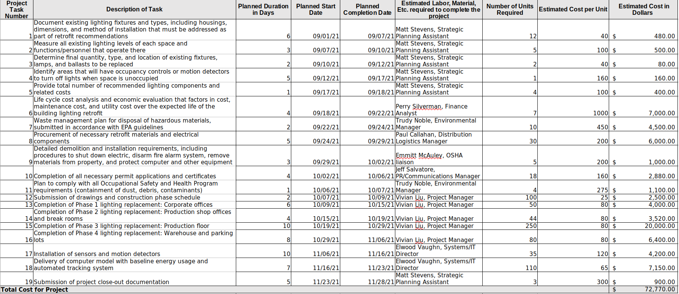
Stakeholder Concerns
It is important to identify and develop a solution for any and all concerns that arise from stakeholders in a project. These should be recorded as soon as they are expressed and they should be updated and tracked in this living document. Each of these concerns is a risk that might cause the project to fail, whether they are large, small, significant or otherwise. Documenting these concerns is a form of stakeholder management and it also makes them more likely to be resolved in a way that is satisfactory for the project team and the stakeholders.

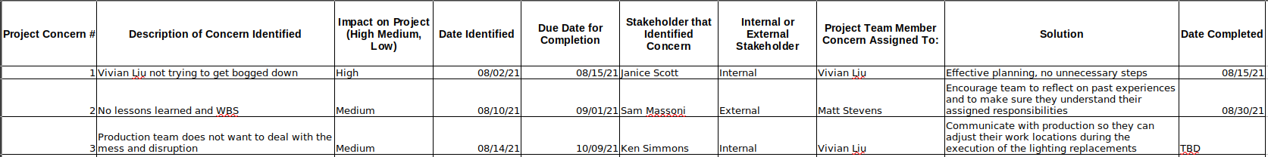

Stakeholder Support
The stakeholder register documents anyone who has something to gain or lose from project execution. These entities can be inside or outside the organization and they may possess differing levels of support and authority. (MindEdge Module 2) It is important to identify stakeholders as early in the process as possible and to keep the register up-to-date throughout the project. The register makes it easier to treat similar stakeholders in a similar fashion. Including each stakeholder’s level of support allows practitioners to ensure that those highly interested are updated on the project’s progress.

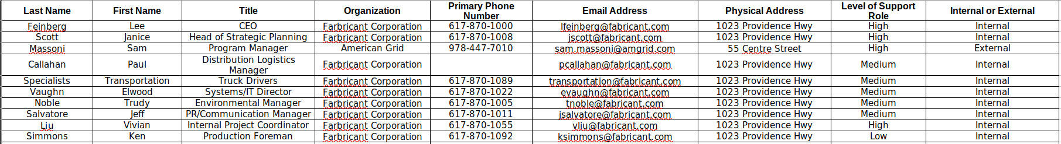

Stakeholder Analysis
Stakeholder analysis is a table similar to the stakeholder register, but it mainly includes information that can be used to develop stakeholder management charts such as the power/attitude/interest grid and the salience model. This table and the charts based on it allow the project manager to formulate strategies for engagement and prioritization. In the salience model, stakeholders are placed in zones designated from 1-8 within a Venn Diagram. Stakeholders in any overlapping zones (4-7) are the most important and their suggestions and feedback should be considered highly. Additionally, categorizing stakeholders often helps identify some who were unforeseen and can then be added to the stakeholder register. (Danda)

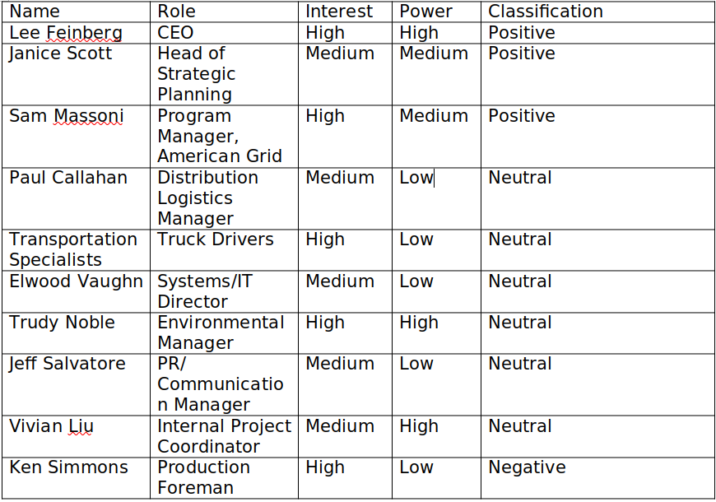
References:
Danda, Darshan. 2020. Analyze Your Project's Stakeholders With The Help Of The Salience Model. Grey Campus. Retrieved from https://www.greycampus.com/blog/project- management/analyze-your-project-s-stakeholders-with-the-help-of-the-salience-model
"Module Three: Project Scope, Planning, and Time Management." 2021. MindEdge Inc. Retrieved from https://snhu.mindedgeonline.com/content.php?cid=87451
"Module Two: Project Selection and Initiation.” 2021. MindEdge Inc. Retrieved from https://snhu.mindedgeonline.com/content.php?cid=87513

